Comp 421 - Project 2

# Relational Translation

Stadiums(sname, location, capacity)

Matches(matchId, mdate, mtime, duration, round, sname)

sname foreign key referencing Stadiums

sname NOT NULL

Teams(country, national association, group, url)

Players(playerId, dob, name, number, position, country)

country foreign key referencing Teams

country NOT NULL

PlaysIn(playerId, matchId, inTime, outTime, yellowCard, redCard, position)

playerId foreign key referencing Players

matchId foreign key referencing Matches

playerId NOT NULL

matchId NOT NULL

Coaches(coachId, dob, name, role, country)

country foreign key referencing Teams

country NOT NULL

Referees(refId, experience, name, role)

Oversees(refId, matchId)   
 refId foreign key referencing Referees

matchId foreign key referencing Matches

refId NOT NULL

matchId NOT NULL

Goals(matchId, occurrence, minute, penalty, playerId, country)

playerId foreign key referencing Players

matchId foreign key referencing Matches

country foreign key referencing Teams

playerId NOT NULL

matchId NOT NULL

Seats(seatNumber, stadiumName)

stadiumName foreign key referencing Stadiums

stadiumName NOT NULL

Tickets(ticketId, matchId, seatNumber, sold)

matchId foreign key referencing Matches

seatNumber foreign key referencing Seats

matchId NOT NULL

seatNumber NOT NULL

Customers(emailAddress, firstName, lastName, address, password)

CreditCards(number, billingAddress, nameOnCard, cvc, expiryDate, emailAddress)

emailAddress foreign key referencing Customers

emailAddress NOT NULL

Purchased(emailAddress, ticketId, price)

emailAddress foreign key referencing Customers

ticketId foreign key referencing Tickets

emailAddress NOT NULL

ticketId NOT NULL

TeamPlays(matchId, country)

matchId foreign key referencing Matches

country foreign key referencing Teams

matchId NOT NULL

country NOT NULL

# Pending Constraints

1. Each Customer has at least one Credit Card associated with them.
2. Each game has exactly two teams
3. Every game has at least one referee and all the appropriate players

# SQL Queries

1. SELECT m.matchId, s.sName, s.location, m.mDate

FROM(

SELECT matchId

FROM goals

WHERE playerId = (

SELECT playerId

FROM players

WHERE name ='Christine Sinclair')

GROUP BY matchId

HAVING count(*) >=1)goalcounts, matches m, stadiums s

WHERE goalcounts.matchId=m.matchId AND m.sName = s.sName;

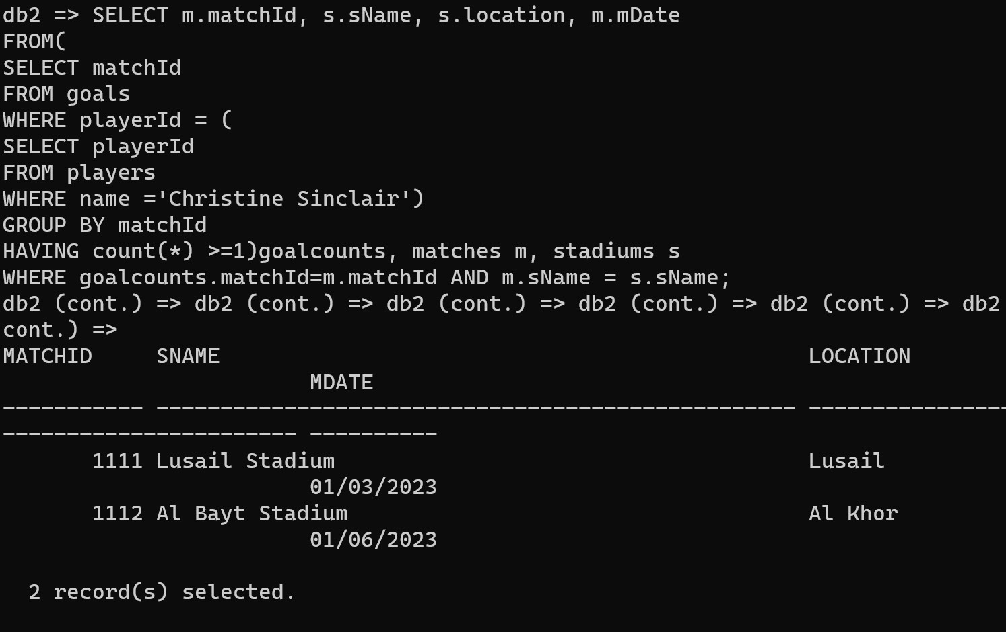

1. SELECT p.name, p.number, p.country

FROM(

SELECT playerId, COUNT(*) pcount

FROM plays_in

GROUP BY playerId)pc,

(SELECT country, COUNT(*) tcount

FROM team_plays

GROUP BY country)tp, players p

WHERE p.playerId=pc.playerId AND p.country=tp.country AND pc.pcount=tp.tcount;

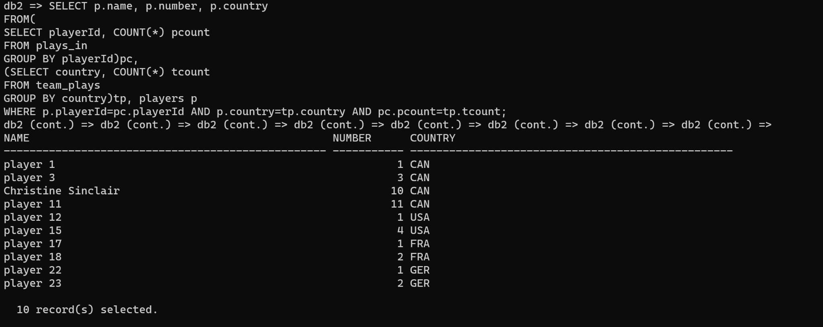

1. SELECT t.country, COUNT(DISTINCT t.matchid) num_matches,

COUNT(t.matchid) num_goals

FROM team_plays t LEFT OUTER JOIN goals g

ON g.matchid = t.matchid AND t.country = g.country AND g.penalty = FALSE

GROUP BY t.country;

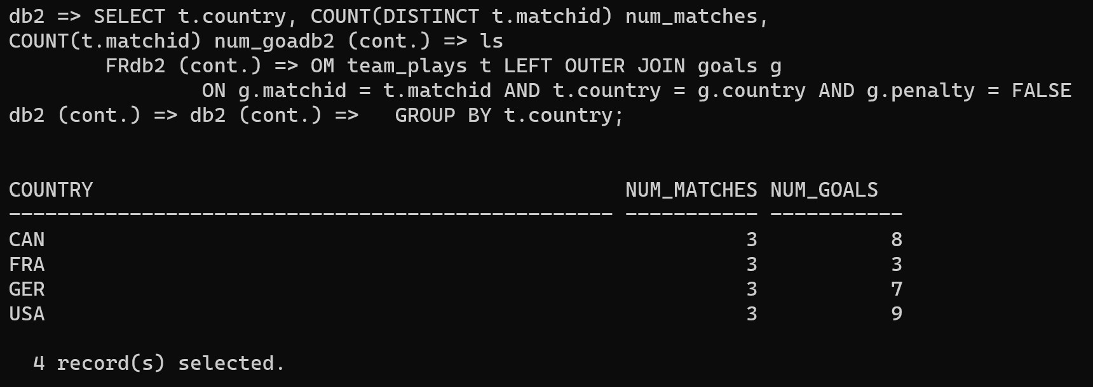

1. SELECT m.matchid, m.sname stadium, COUNT(t.ticketid) total_tickets,

(SELECT COUNT(ticketid)

FROM tickets

WHERE tickets.matchid = m.matchid

AND sold = TRUE) AS sold_tickets

FROM matches m LEFT JOIN tickets t

ON m.matchid = t.matchid

GROUP BY m.matchid, m.sname

ORDER BY m.matchid;

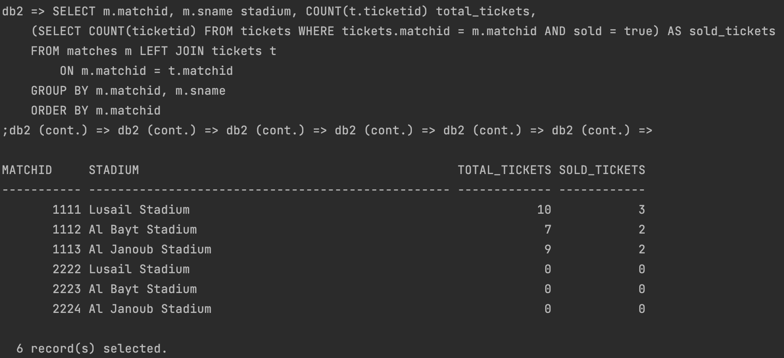

1. Finding the match, minute, the scoring player name and which country they are from of all goals scored in the last half of the game, but not in penalty (during game time).

SELECT g.matchid, g.minute, p.name, p.country

FROM goals g, players p

WHERE g.playerid = p.playerid AND g.minute >= '00:30:00' AND g.penalty = FALSE

ORDER BY g.matchid;

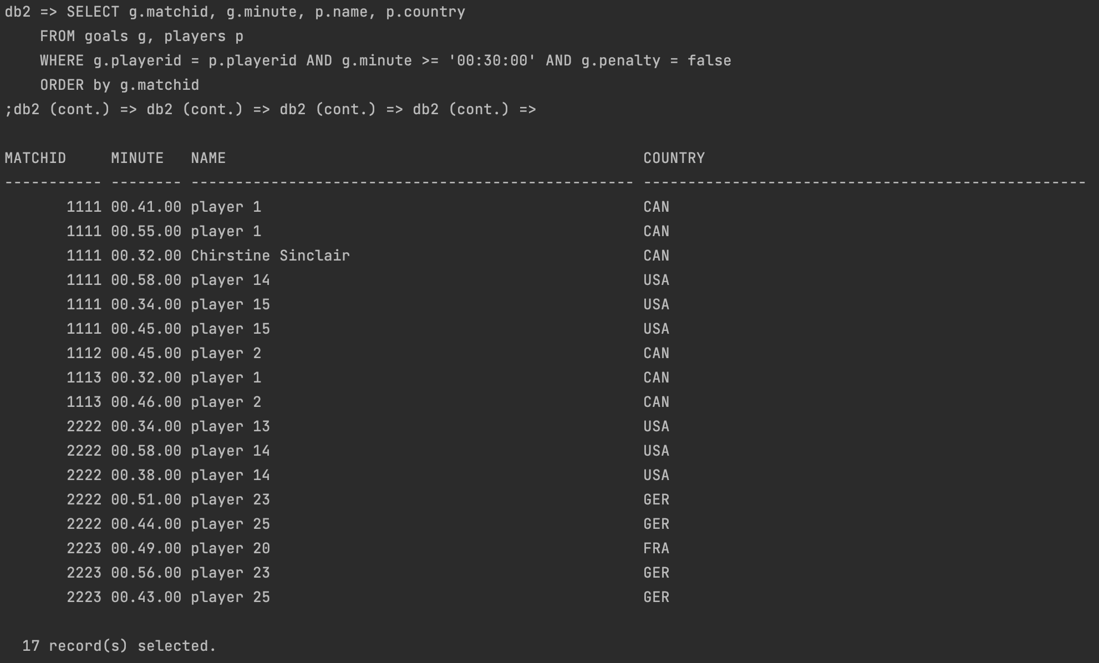

# Player Information

1. CREATE VIEW PlayerInfo (name, number, dob, country, nationalassociation, group)

AS SELECT p.name, p.number, p.dob, p.country, t.nationalassociation, t.roundgroup

FROM players p, teams t

WHERE p.country=t.country;

1. 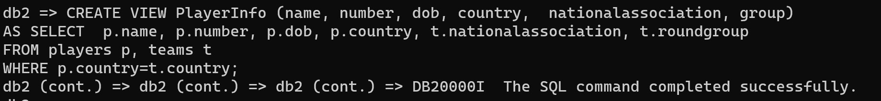
2. 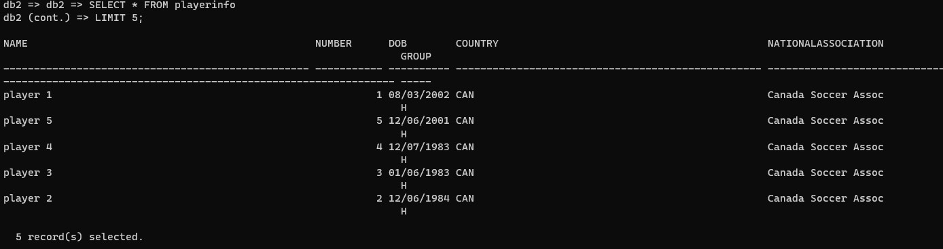
3. 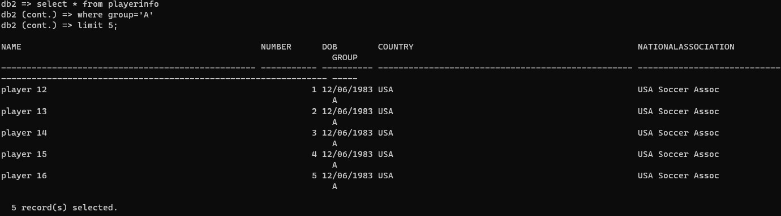

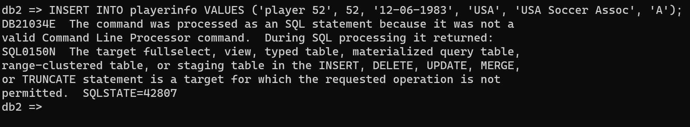

This happened because a VIEW is just a definition, not a set of tuples thus there is no set of tuples to insert into. Additionally, VIEWs are for presenting information not for manipulating it.

# Check Constraints

ALTER TABLE matches

ADD CONSTRAINT check_dates CHECK (mDate >= '2023-07-20' AND mDate <= '2023-08-20');

This check constraint checks if the dates of matches are within the proper date range - between July 20th and August 20th, 2023.



